
Eryrys Gardening Club Committee
Graham Richards 07484669687
Sue Hanahoe 07505214843 susanhanahoe@gmail.com
Norma Wright 07749046632 norma_helen_wright@yahoo.co.uk

Eryrys Gardening Club
Dear Gardening Enthusiasts, please do feel free to contact Graham, Sue or Norma, if you have ideas of where to go for trips. What topics you want for talks or workshops? Most of all, if you can help by giving a little talk or demonstration? We would love to hear from you!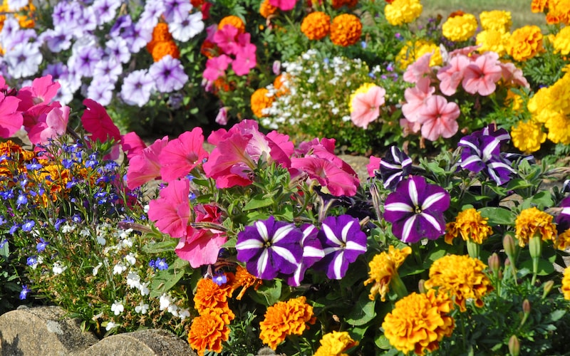Thursday 15th October 2026, 7pm. £3 Canolfan Dewi Sant, Eryrys Alan Evans who has visited the club many times will be giving a talk and presentation on ‘Bedding Plants - Fast-growing flowers or foliage plants used to fill garden beds, borders, and containers with vibrant seasonal colour’. With plenty of tips and good advice; Followed by 'Question Time'.
To be done in the Garden in October;
- Protect tender plants: Plant garlic
- Rake your lawn, give it one final cut and/or lay new turf
- Clean out bird boxes and keep bird feeders topped up
- Cut back herbaceous perennials that have died down
- Plant spring cabbages
- Create a leaf mould bin
- Harvest nuts, apples and pears Plant winter pansies: Prune roses

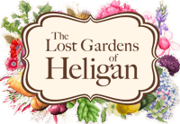Thursday 19th November 7pm. £3 Canolfan Dewi Sant, Eryrys Film on ‘The Lost Gardens of Heligan’ – a magnificent 200-acre estate that was left abandoned and overgrown for decades after World War I before being famously rediscovered and restored in 1990. Whilst you have a cuppa, there will be a quiz by Sue Hanahoe.
Saturday 5th December 2026 1pm-3.30pm Canolfan Dewi Sant, Eryrys £15 Christmas Wreath / Willow Workshop – with mulled wine and mince pies!!
For enough spaces and catering purposes we do prefer if you will book a place, with Sue, Graham or Norma. Please support the club!

Thursday 17th December 2026 at 1pm.
A Social Lunch/Afternoon for All!
Come and join us in The Sun Inn, Eryrys Please try to come, booking is preferred for catering numbers; Graham, Sue or Norma.
Thursday 14th January 2027,7pm £3 Martyn Holland Chair of ‘Friends of the Clwydian Range and Dee Valley National Landscape’. Martyn has inspiring stories, conservation updates, local projects and news. from the National Landscape Team. Hoping if you 💚 Love the Clwydian Range & Dee Valley then you will ‘Become a Friend’; helping care for and protect this special place for future generations. Find out more at www.friends.cymru or email hello@friends.cymru.🌿 Together, we can help keep this landscape special for everyone!
Thursday 18th February 2027,7pm £3 Philip Culver; Presentation on ‘The Wild Flowers of the Eastern Mediterranean’

