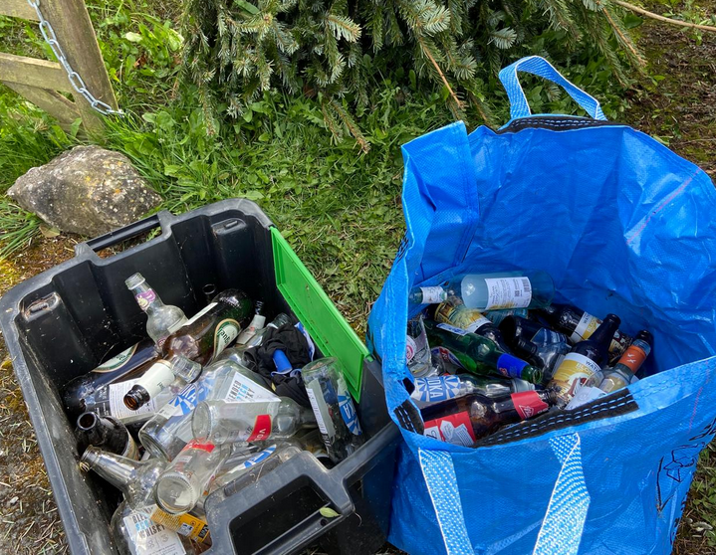
LLANARMON YN IAL COMMUNITY COUNCIL
PLEASE STOP DUMPING YOUR BOTTLES
IN THIS GRAVE YARD.
THERE ARE NOW CCTV CAMERAS FITTED
IF YOU ARE CAUGHT ON CAMERA THE COMMUNITY COUNCIL WILL REPORT YOU TO THE POLICE AND YOU WILL BE PROSECUTED AND FINED

