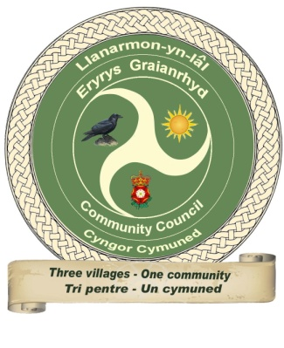

Llanarmon Yn Ial Community Council

Section 1: Biodiversity Report for Year Ending 2023 - 2025

Section 2: Action Plan for 2026 - 2028

Reference: Environment (Wales) Act 2015 Part 1 – Section 6

The Biodiversity and Resilience of Ecosystems Duty

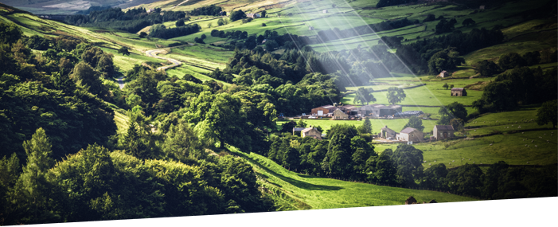
‘Never doubt that a small group of thoughtful,
committed citizens can change the world.
Indeed it is the only thing that ever has.’
• Margaret Mead

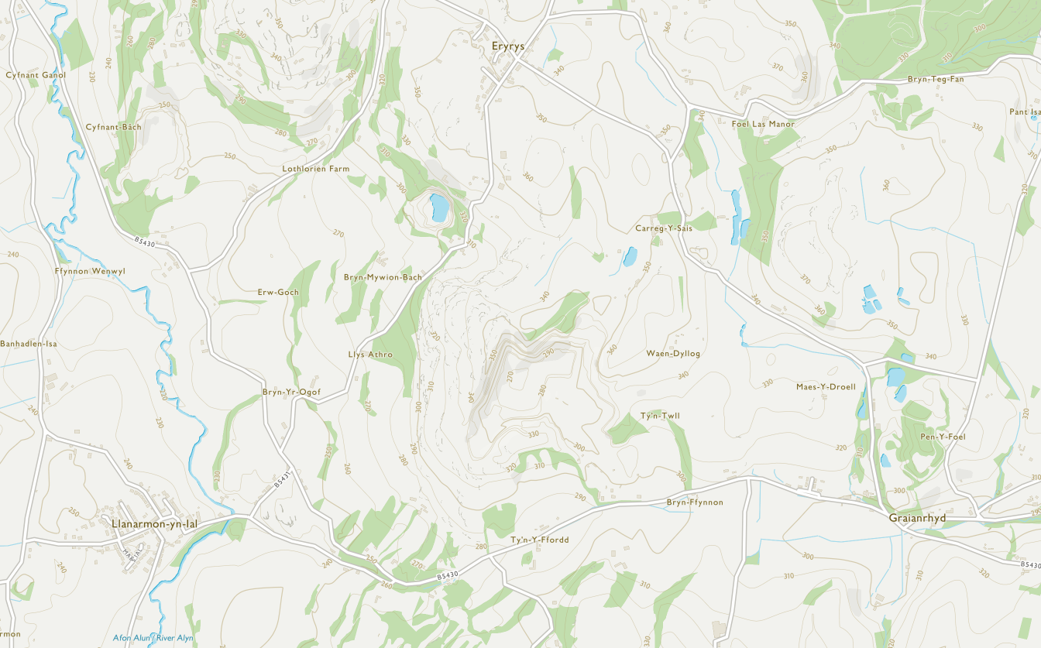

Section 1: Introduction
Llanarmon yn Ial Community Council is a small rural elected tier of local government. There are up to ten membership places, but we have only eight Community Councillors at present. They represent around 1300 residents, with a budget of approx £23,500 covering three villages Eryrys, Graianrhyd, and Llanarmon yn Ial.
Biodiversity is the variety of life on earth which includes all species of plants, animals and the natural systems that support them. Llanarmon yn Ial Community Council has a duty to have regard for the conservation of Biodiversity when undertaking its functions.
Llanarmon yn Ial Community Council has a range of activities and services within the community which have an impact on biodiversity. These include:-
- The upkeep of 2 playing fields; Llanarmon yn Ial Playing Field and Graianrhyd Community Field
- The upkeep of 3 cemeteries; Maes y Droell, Graianrhyd Cemetery: Dewi Sant, Eryrys Cemetery: St Garmon, Llanarmon Cemetery- with a Hearse House Grade 2 listed building and a War Memorial
- 4 defibrillators - held at 1. Canolfan Dewi Sant, Eryrys 2. Telephone kiosk, Graianrhyd 3. Llanarmon Community Shop 4. Llanarmon Old School Room. Thanks to local residents who raised the funds
- 2 ex telephone kiosks - Graianrhyd and Eryrys; both used as libraries with books, DVD,s ,magazines, knitting wool and free plants in the summer
- 2 bus shelters and various notice boards in the locality
- 14 community planters: including two new ones in Llanarmon Playing field and two in Graianrhyd Community Field encouraging the community to grow flowers
- Maintaining a flower/bulb planting programme; blue-bells, snowdrops, daffodils
- Maintaining a tree planting programme
- Creating habitats for birds, bees, bats, bugs, insects, and hedgehogs
- Working with LFPRA to build and locate bird and bat boxes around the local area
- Supporting Ysgol Bro Famau
- Making payments for the cost of the local community website
- Actively promoting the Annual Litter Pick, in all three villages
- Refilling dog-pooh bags in the community
- Giving grants towards the cost of insurance for Canolfan Dewi Sant.
The Council promotes sustainability and biodiversity by:
- Using local materials and craftsmen whenever possible when undertaking work in the Community
- Ensuring every Land Management project considers Biodiversity and Sustainability in the early stages of development
- Sustainable awareness within procurement; as shown in purchasing Llanarmon Playing Field equipment
- Ensuring Planning applications consider biodiversity and sustainably
- Community Engagement with residents,\ Ysgol Bro Famua and local organisations

Actions Carried Out

Embed Biodiversity into decision making at Community Council Meetings by:
  - The Council’s commitment to biodiversity and natural areas is reported in the annual report
  - Considered biodiversity when reviewing planning applications
  - Ensured biodiversity was considered when identifying and planning new projects
  - Promoted courses for volunteers and Councillors
  - Ensuring a number of initiatives under their sustainable procurement plan.

Raised awareness of biodiversity and its importance by:
  - Posted details of actions taken by the Council to help biodiversity on the website via minutes
  - Used notice boards and information boards in bus shelters and defibrillator station to display descriptions of local flora, fauna, and wildlife
  - Encouraged the community to continue volunteering to maintain all flower – boxes and green spaces with a respect for nature
  - Inviting residents to harvest and use the many planted herbs and fruits (apples and plums) grown in Graianrhyd Community Field.
  - Had promoted courses on dry-stone walling – traditional rural crafts run by Country Service Countryside, through the Ranger/Project Officer - Clwydian Range & Dee Valley AONB. Now awaiting new funding and finding a supply of suitable stone.

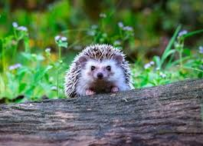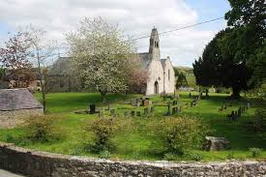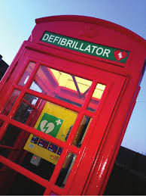
Eryrys ‘Local’ Hedgehog Llanarmon St Garmon’s Cemetery Graianrhyd defibrillator in kiosk

Safeguarded principal species and habitats by:
- Support Hen Ardd with the habitat for the Red Crested Newts and wildlife area
- Managed all hedgerows in the winter months when the wood lay dormant and avoided working in the bird nesting season from March to September
- Regular visits to inspect all areas to identify anything that needs attention.
- Undertaking any works identified during said inspections.

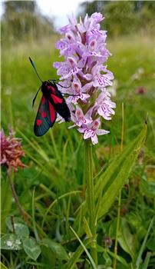
Common spotted orchid in Maes y Droell Cemetery
Monitored by White Oak Properties Services (Council’s main green spaces contractor)
Dr Hugo Watts reported: “The team have found this season that orchids are resurging across the local community, particularly in Maes y Droell rear meadow, which is a really good sign. These plants offer great support for our local butterflies and moths. We’ve seen more orchids locally now. This indicates our meadows are working as a great highway for plants, insects and animals to move between these county sites, and in doing so, are helping to increase biodiversity within our community.”
“What’s a key marker as well is orchids produce seeds which must come in contact with a special type of mycorrhizal fungi that will help the orchid seed germinate and aid it in its early growth. Each orchid tends to have particular mycorrhizal fungi that it partners with, so unless the soil conditions are right for the fungi, we won’t get the orchids. Logging this resurgence of orchids shows the project is really working now in supporting the recovery of our meadows and improving the resilience of our nature.”
Llanarmon yn Ial Council, believe: “This is a crucial project for bringing back a habitat that has almost disappeared since the 1930s and this resurgence of orchids shows we are going in the right direction in supporting our local nature that has been impacted by climate change”.

Maintained existing and created new habitats by:
- Trimmed hedgerows during dormant growth season
- Planted tree whips in the Llanarmon Playing Field, provided by the Woodland Trust - using mixed planting known to encourage wildlife and nesting birds.
- Removing dead and diseased trees to prevent them infecting others.
- Removing fallen trees in St Garmon and Dewi Sant and using the branches to create wildlife habitats.
- Pruning trees to maintain their health and encourage more growth.
- Pruning to promote healthier growth and attract pollinators.
- Strimming dedicated wildflower areas once a year, in particular Maes y Droell l -has orchids.
- Leaving an area around the boundary inside of Llanarmon and Graianrhyd playing fields untouched to attract more insects, butterflies, bees, and other pollinators.
- Planting new mixed hedges in Llanarmon Playing Field, whilst creating a corridor to separate the ‘dogs allowed area’ the areas using species known to attract wildlife and nesting birds.
- Providing dog –pooh bags in both playing fields
- Planting other areas with berry producing shrubs to provide winter food for birds.
- Establishing bug hotels and wildlife habitats in Llanarmon Playing Field
- Building and placing bird and bat boxes around the community
- Purchasing 10 swift boxes shared around the whole community
- Encouraged by the active Conservation Society with building and placing bird and bat boxes around the area. The Conservation Society achieve many projects including replacing stiles; as the Llanarmon Community has the highest number of footpaths in Denbighshire.
- Placing additional planters around the area.
- Leaving mole hills untouched until after the breeding season.
- The 2 benches and flowering plants are now established as a “Reflections Memorial Garden”, in St Garmon’s churchyard

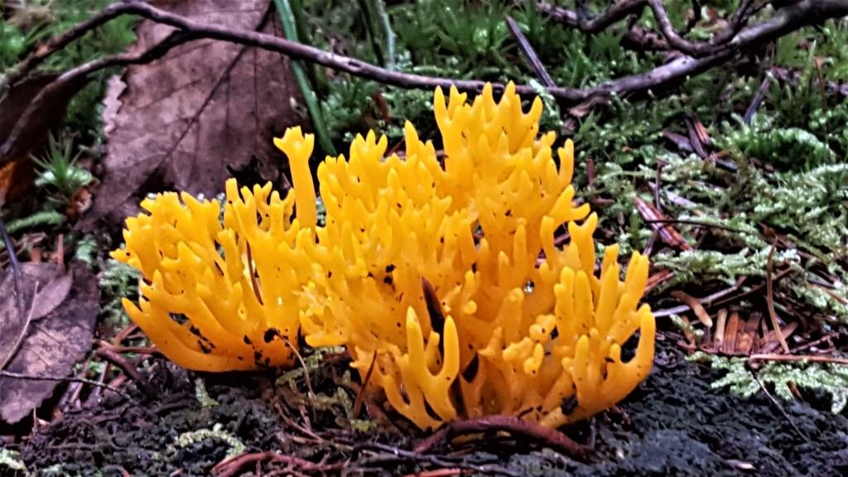
Locally found Staghorn Fungus Calocera

Tackle & Reduce Negative Factors by:
- Support and actively promote biodiversity and sustainability with a sensible replanting policy using native species - as in the rear of Llanarmon Playing Field
- Identified new biodiversity projects in the community ; then budget for and provide funding as appropriate securing grants where possible
- Involve the community

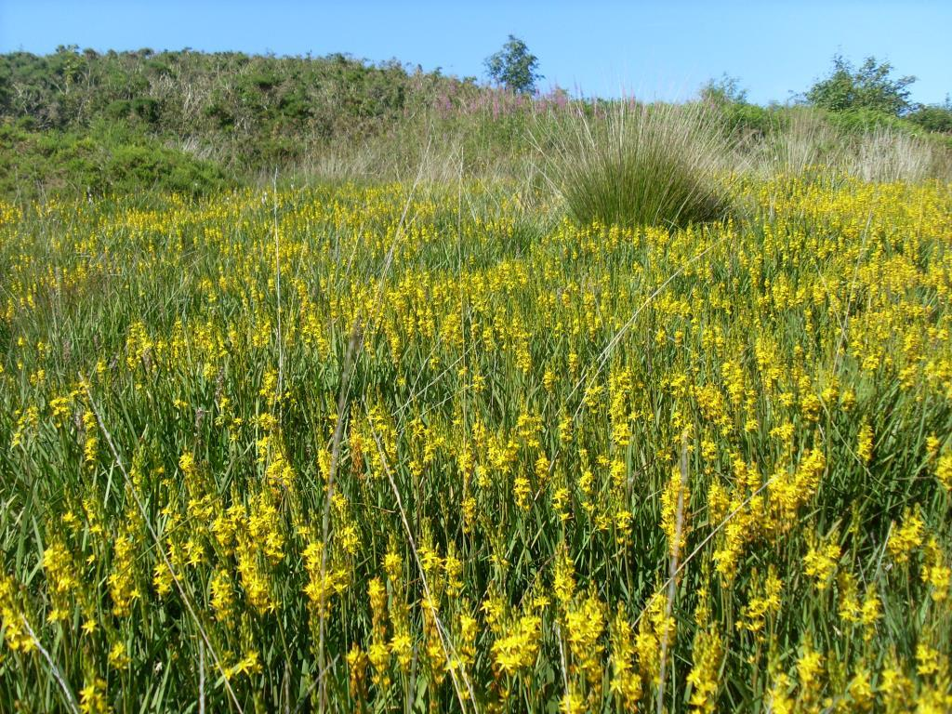
Local Bog Asphodel
Our knowledge and education improved by:
- Continually asking for advice, listening to, and engaging with all outside agencies i.e. North Wales Wildlife Trust, and other organisations - attending meetings
- Actively engage Denbighshire Country Service Countryside, through the Ranger/Project Officer - Clwydian Range & Dee Valley AONB to promote Hen Ardd nature reserve
- Continue engaging with Keep Wales Tidy to promote Graianrhyd Old School field.
- Work with the Biodiversity officer in Denbighshire County Council to increase knowledge and understanding of local issues and adopt best practice whenever practicable.

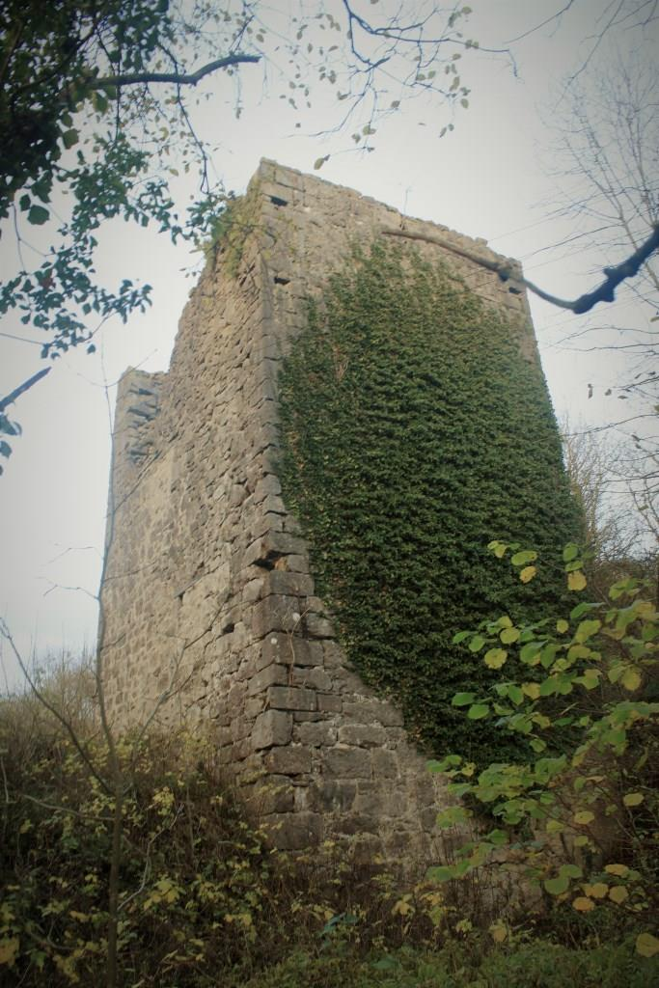

Supported and rewarded community efforts by:
- Continued involvement in the Community for our open areas, and places of industrial heritage
- Encourage organisations receiving grants from Llanarmon yn Ial Community Council to actively contribute to supporting biodiversity within their activities
- Working with agencies such as our Conservation Society and North Wales Wildlife Trust
- Encouraging and recruiting volunteers from the community to contribute to the activities

Monitoring and Reviewed by:
Llanarmon yn Ial Community Council sincerely thank Mr Gareth Bryan our H&S Warden Volunteer. He carried out a weekly ,visual inspection and monitoring service, along with an excellent, detailed written report of Llanarmon Playing Field.
- Biodiversity included annually, or when requested on the agenda for council meetings
- Visual inspection throughout the year and minuted
- Councillors report on progress of individual projects, then identify actions needed to complete work within a ‘reasonable’ time scale
- Clerk maintaining records and identifying potential funding sources.
- Projects being reviewed annually by Councillors and recorded by the Chair in the Annual Community Council Report.
- Evidenced by an Annual Report, and website.

Llanarmon yn Ial Community Council

Review of 1st January 2023 – 31st December2025

Environment (Wales) Act 2016 Part 1 – Section 6/7

The Biodiversity and Resilience of Ecosystems Duty

What Has Worked Well

The Planting bulbs and seasonal bedding plants in the 14 planters located in the three communities/villages.

In March 2025 LCC thanked the Graianrhyd community for replacing and filling the damaged flowers boxes.

Planting additional daffodil, bluebell and snowdrop bulbs; At the entrances, and around St Garmon Llanarmon yn Ial Church, Dewi Sant, Eryrys and Maes y Droell cemeteries. Where the verges and selected areas are left uncut by White Oak Service, to aid the existence and growth of both our wild flowers and planted one.
- Maes Y Droell cemetery repairs to the back stone wall; then creating a pedestrian entrance between the existing graveyard and the higher extended meadow piece.
- Llanarmon playing field - Phase 1 work was completed of hedge planting for the creation of a wildlife corridors along with a number of fruit trees, once established will provide fruit for the Community.
- Llanarmon and Playing Field: biodiversity plans- S Latham organised the supply of seeds of Welsh endangered / rare plants. Along with the help of Dr Hugo Watts some seeds were able to go in up to the end of Autumn, others are Springtime. These were:- Welsh Poppy, Bright Yellow flower head; Welsh Bluebell, Government licensed seeds License No.63058:OTH:WCA:2015; Gold Y Mor, Goldilocks Aster, extremely rare endangered and source of nectar for insects; Saets y Waun, Salvia Pratensis, currently extinct in the wild in Wales. Clychlys ymledol, Campanula patula, critically Endangered Native Welsh Wildflower; Cenhinen Bedr, Narcissus obvallaris, a dwarf daffodil, is of conservation interest, preservation efforts focus on protecting its natural sites and encouraging cultivation in gardens to protect this national treasure.
- Transforming disused telephone boxes into local information centres t and leaflets on the local area, whilst one housing the defibrillator; and the other Dog bags, cycle repair kits and first aid boxes; both holding a good supply of books and DVD’s etc
- Working with Country Service Countryside Ranger/Project Officer - Clwydian Range & Dee Valley AONB, Holding a workshop making ‘bird & bat boxes for our community’.
- Installing ‘Bug Hotels’, and Hedgehog homes.
- Requesting BT leave a hollowed-out electric pole un-felled in Maes y Droell Cemetery for the resident Woodpeckers.
- Installing rain-barrels to collect water for watering plants at Graianrhyd, Dewi Sant and Llanarmon Field.
- Planting trees to celebrate the Queen Elizabeth’s Jubilee; with distinguished plaques.
- Planting 6x20ft: Sycamore and Silver Birch in Llan graveyard. Cherry and Oak in Llan field; Maple and Rowan in Dewi Sant: trees provided by local residents and Tom Hiles DCC Tree Officer.
- Weather proofing the wooden street furniture to prolong its life.
- Reviewing office paper to ensure it’s from sustainable forests, and reducing the amount of paper used.
- Purchased street furniture/ several benches and picnic tables all from recycled from plastic bottles.
- Purchased new play equipment with a generous Lottery Grant, from sustainable resources and installed by local craftsmen; completing Phase 2 of Llanarmon Playing Field project.
- LCC purchasing from DCC two litter/dog bins and empting services. Thus, ending the terrible habit of a dog owner inserting over 40 bags of dog-pooh into a stone wall in Eryrys.

What Have the Barriers Been
- Apathy
- Lack of volunteers
- Lack of understanding of Biodiversity
- Raising of funds

Minuted problems have been:-

Damage reported, with hedge planting being removed from the Llanarmon Playing field.
- Internal fence work maintains a barrier to fence off the children’s equipment and football pitch from dogs and dog fouling. The remaining side and top area is open to everyone including dogs. It was not designed or fenced off as a designated dog area, dogs should still be on leads and fully under control, with all fouling being picked up, bagged and binned. A ban of dogs had been suggested on the playing field due to the risks of dog attacks and contamination from fouling so the compromise was to fence off the play equipment.
- Persistent dog fouling not being pick-up by inconsiderate dog owners; has lead to discussions by the council to consider banning dogs altogether from the playing field. It had led to the community council purchasing and installing cameras to monitor the situation.
- Llanarmon Playing Field gate broken, with locks on both gate vandalised enabling entrance for local youths to race/ rally cars on the field.
- Benches broken and placed on the skate-park
- Unsociable behaviour reported within the Llanarmon Church yard, with many empty glass alcohol bottles being dumped on graves and persistent dog fouling that is not being responsibly picked up; led to the community council purchasing extra cameras being installed to monitor the situation.

New sustainable Playing field equipment being enjoyed!!
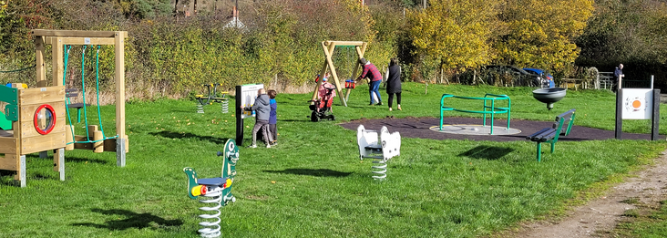

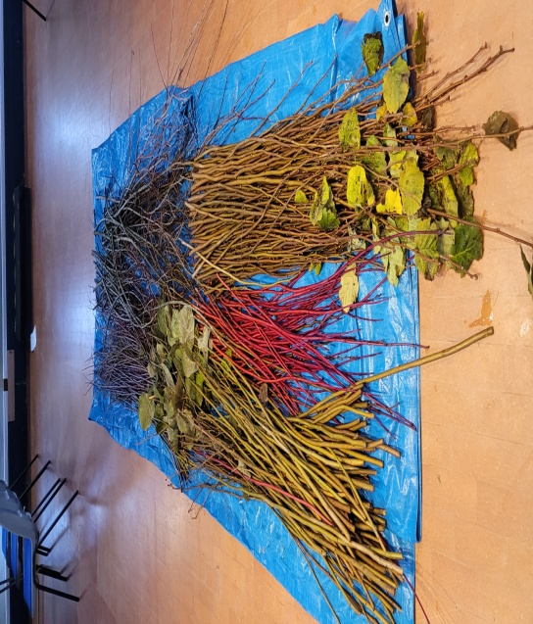 | 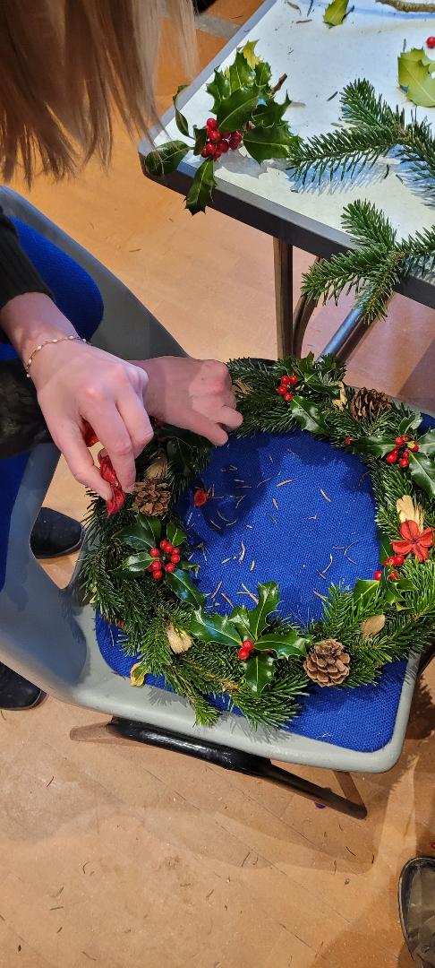
Variety of local resources for Wreaths making. Using the beauty of wild nature. | Lovely Christmas Wreaths made by local residents with locally grown items. Bringing the community together.
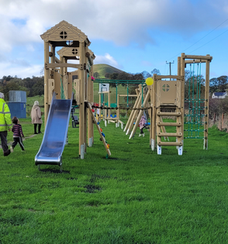Newly installed sustainable wooden play equipment on Llanarmon Field 2025 | 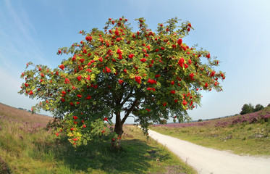Planted Rowan Tree - Mountains Ash. The health of local trees are carefully monitored and maintained.
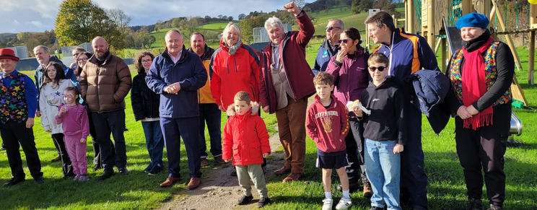
Official Opening of New Play Equipment on Llanarmon Playing Field 2025 thanks to Lottery Grant

Section 2:Biodiversity Action Plan
1st January 2026 – 31stDecember 2028
Duty Under section 6 of the Environment (Wales) Act 2016
Llanarmon yn Ial Community Council fully recognises the need to minimise our own impact on the environment and play our part in addressing the threats posed to wildlife and natural habitats by human activities.
Our ACTION PLAN for performing the Duty over the next three years includes updated objectives for the period 1st January 2026 to 31st December 2028; up to the next statutory reporting deadline and have consolidated our objectives with updated key actions.
Llanarmon yn Ial Community Council reports can encourage beneficial changes relating to maintaining and enhancing biodiversity in Wales. Responding to the climate and nature emergency is one of the four key themes that drives our performance and work programme.
Over the last three years, we examined a number of studies which covered biodiversity and ecosystems considerations. As Llanarmon yn Ial Community Council owns and managed land, we therefore have an opportunity to carry out activities that support biodiversity and ecosystem resilience as small community councils do. We fully recognise the need to minimise our impact on the environment and play our part in addressing the threats posed to wildlife and natural habitats by human activities.
Our Action Plan for performing the Biodiversity and Resilience of Ecosystems Duty over the next three years is an organic plan to be regularly reviewed and evaluated along with a commitment for this Plan to be reviewed, and, amended where appropriate by Full Council on an annual basis.
Goods & Services
Our procurement activities have followed a hierarchy that prioritises avoidance, reuse, refurbishment, and recycling before purchasing new. Where purchase is the viable option, our preferred route of sustainable procurement is via Welsh and UK Government frameworks that follow the Government Buying Standards. We apply a good practice to help us perform the duty when contracting for goods and services. This is specifically, in relation to our procurement of purchasing play equipment; office resources, IT equipment and ground maintenance. We prioritise sustainability, energy efficiency and device reuse. Our use of consumer single use plastics is also now very low. We use laptops and smart phones; the printing of meeting papers is now generally discouraged except where it is essential.
Planning
As a statutory consultee, active discussions have also taken place with developers at the early planning stages to ensure biodiversity is taken into account when building new homes within the community. This action is in line with the recent Planning Policy (Wales) Act 2016 which states: "planning authorities must seek to maintain and enhance biodiversity in the exercise of their functions. This means that development should not cause any significant loss of habitats or population of species, locally or nationally and must provide a net benefit for biodiversity".
Graianrhyd
1. Pay a honouriam to a volunteer to Kick Start/ assist long-term projects – Graianrhyd community garden/ litter picking /brushing out bus shelters/ cleaning kiosks and notice boards etc.
Action: Mentioned in minutes and posters up in villages/ social media.
2. More information about Biodiversity.
Action: Three large artistic Nature outdoor information boards will be bought 2026. They will be installed on the rear wall of the new hand- crafted shelter, made by Gwyndaff Jones.
3. Pay to prune the apple and plum trees in Graianrhyd.
Action: Trees will be pruned (Hugo Watts) when it’s the correct time of the year.
4. Set up the vegetables boxes with soil then plants.
Action: Cllr Kevin Ford has put boxes in place and some soil in; they need much more soil.
5. More bulbs/Plants needed in some flower boxes on the kerb side.
Action: Thanks to Sue Hanahoe for plants and herbs in the boxes. Thanks to Ceris Jones for replanting the 2 trellised planters with geraniums and wildflower seeds. More Plants will be bought locally and the gardening club sale in June.

6. Set up the flower/herb boxes with soil then plants.
Action: G Jones had put flower boxes in place but no soil in yet; Plants will be bought locally and if possible gardening club sale in June.

7. Participation in the Local Places for Nature initiative One Voice Wales (promoted by Keep Wales Tidy) to host a wildlife garden at Graianrhyd Community Field. This project comprised of a raised bed, trellis work, bird and insect habitat boxes and is being set up with the help of members of the Graianrhyd Eryrys and Llanarmon community.
A new large wildlife pond liner has recently been delivered, notices about why the grass will be cut less and later in the year, along with many wild flower seeds.
Action: Cllr K Ford is looking for more volunteers to carry out this work; but he has made a start.
8.*Create a BBQ area for social meetings; small amount of play equipment wanted.
Action: This can be discussed at a council meeting
Llanarmon Playing Field
1. Plants had been bought and installed in the flower boxes by N Wright.
Action: Boxes need attention and refilling.
2. Wild Flower Area Wanted.
Action: Steve Latham has organised the supply of seeds of Welsh endangered / rare plants; some of the seeds were planted September 2025 and more to up to the end of Autumn, others are Springtime. This will enable the Council to satisfy the Bio Diversity request including:- Welsh Poppy, Bright Yellow flower head; Welsh Bluebell, Government licensed seeds License No.63058:OTH:WCA:2015; Gold Y Mor, Goldilocks Aster, extremely rare endangered and source of nectar for insects; Saets y Waun, Salvia Pratensis, currently extinct in the wild in Wales. Clychlys ymledol, Campanula patula, critically Endangered Native Welsh Wildflower; Cenhinen Bedr, Narcissus obvallaris, a dwarf daffodil, is of conservation interest, preservation efforts focus on protecting its natural sites and encouraging cultivation in gardens to protect this national treasure
3. More information about Biodiversity.
Action: Three artistic Nature outdoor information posters/lecterns are being priced, to be installed.
Maes y Droell
1. Rear Meadow of Graveyard looking uninviting.
Action: July 2025 reported by Dr Hugo Watts a host of Common Spotted rare orchids found in the grave yard; with a good show of bluebells and daffodils. Front entrance of graveyard and Meadow at the rear needs more welcoming trees and plants/bulbs.
Eryrys, Village
1. Promote Hen Ardd and improve walkway/notice boards/ availability to access/ create car park
Action: DCC had been contacted many times, along with Country Services. This is common land and a SSSI Site; therefore, Llanarmon Community Council cannot work on the site without a licence and permission. DCC state no funding is available. Unfortunately and most frustratingly they show no interest in upgrading this lovely piece of land, which the community council feels is going to waste. The local school has stated lessons could be held there to teach the children firsthand about our local Biodiversity and Resilience of Ecosystems
Dewi Sant, Eryrys
1. Graveyard railings and gates need refurbishing to a high standard.
Action: Front of graveyard railings and gates have been refurbished to a high standard.
2. Front of graveyard and Meadow at the rear needs more welcoming plants/bulbs.
Action: G Richards has planted many bluebells at the front of the graveyard and they look wonderful. More are required in the rear.
3. The Old Street light at the entrance to the graveyard is no longer working and needs replacing.
Action: New Victorian Street lamp bought and installed – looking really charming.
4. Unfortunately, there are a large number of rats in the graveyard
General
1. Make and buy/ posters/signs ‘No dog fouling’.
Action: many posters and signs have been made and purchased and installed in the community. This is really an ongoing problem with Graianrhyd and Llanarmon playing field, dog owners not picking up, their dog’s mess.
2. Buy /make bug houses/ hedgehog home bird boxes for local wild habitat etc
Action: April 2025 Ten swift boxes were purchased by the council and Kevin Ford installed them, around the community. Kevin Ford made Hedgehog homes and installed them around the community. They will continually be monitored, and viewed via the wildlife cameras.
3. G Jones made and installed bug homes, along with bird boxes in Graianrhyd Community Field.
Action: Bird boxes need installing in the trees.
4. Install Nature Cameras, and CCTV to prevent dog fouling, and a large regular, quantity of glass alcohol bottles dumped in Llanarmon graveyard.
Action: Council installed CCTV cameras in the graveyard, which need to be monitored. Llanarmon Playing Field has also has a camera fitted.
5. Litter in the Community
Action: Litter pickers and sack holders were bought in April 2025 for use with the annual Conservation Society Litter Picking Day. However, it was a very poor turn-out of volunteers. It was hoped that another day could be arranged. In addition, H&S Park Warden Gareth Bryan and Cllr Steve Latham, John Hanahoe and several local residents in the community regularly help pick up litter; so they keep a litter picker at hand for when they walk about the community .
6. Grass Cutting: Residents are asked to remember that although the grass vergers and selected areas of our graveyards and playing fields in all three villages, may become long at times; they are left intentionally to aid the existence and growth of both our wild flowers and planted ones e.g. waiting until the daffodils/bluebells have finished; waiting until the rare orchids have finished in Maes y Droell. LCC are actually being asked not to mow until after May; DCC are also adopting this policy.
What Changes are Planned
- Arrange for Councillors and volunteers to continue to attend awareness training courses and receive relevant training so they understand the requirements of Biodiversity and sustainability.
- Working closely with the Conservation Society; and all other local societies.
- Invite speakers, hold training sessions in our community i.e. DCC Planning Officer; Highway Officer; School Head teacher/ Governors; Youth Club Representatives from DCC; Mothers Union other interested locals.
- Encourage and support positive community solutions and join together. Identifying potential biodiversity projects around the area; in particular upgrading Hen Ardd; with DCC help.
- To make Hen Ardd more accessible to all, with an emphasis on improving Educational opportunities for Ysgol Bro Famua to attend for outdoor lessons.
- Prioritise projects by cost, resources needed and how easy/ difficult it may be to complete.
- Include funding for biodiversity projects when setting the precept.
- Creating , planting a small community garden / small orchard in conjunction with North Wales Wildlife Trust, using native plants and fruit trees on the Graianrhyd Community Field; with the aim to grow more fruit a, vegetable and herbs to share in the community.
- The possible creation of a composting area in one of the community areas
- Prizes for the Llanarmon Country Annual show – Children ‘growing something’
- Giving a prize/donation to the local primary school for ideas they will do, to help the environment and biodiversity.
- Promoting Councillors and volunteers to take part, and promoting the Annual Litter Pick ‘Do it with us!’
- Nature & Information board to increase visitors knowledge and understanding in Llanarmon Playing Field concentrating and inclusive of the Welsh language.
- Prepare and publish the next 2026-2028 Plan, setting out what Llanarmon yn Ial Community Council proposes to do to comply with the duty.
